**18/12/2020 User Stories on Jira**

**A user story is an end goal expressed from the user’s perspective**​

* Focuses on what they want to do rather than how to do it​
* These users can be external or internal​
* They should be expressed in simple language that everyone can understand​

​

**Agile user stories typically have multiple parts to work on (sub-tasks) and are part of a bigger portion of work (epics)**

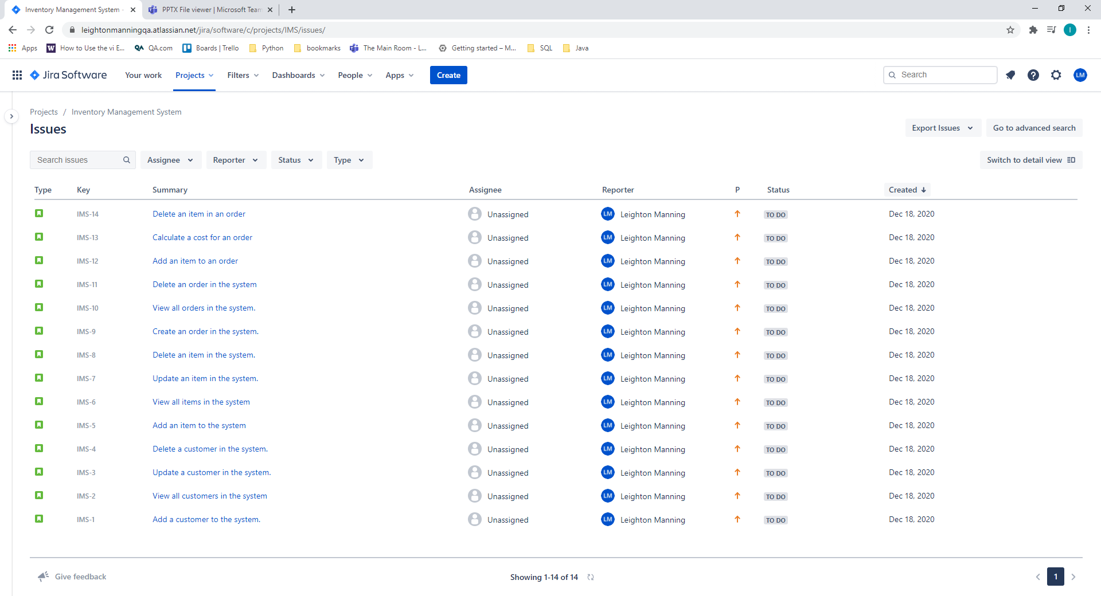

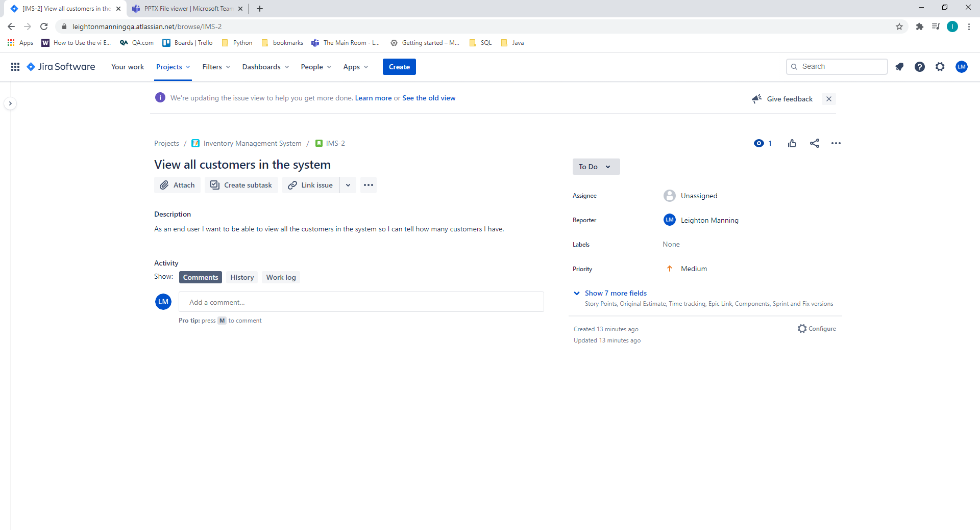user story

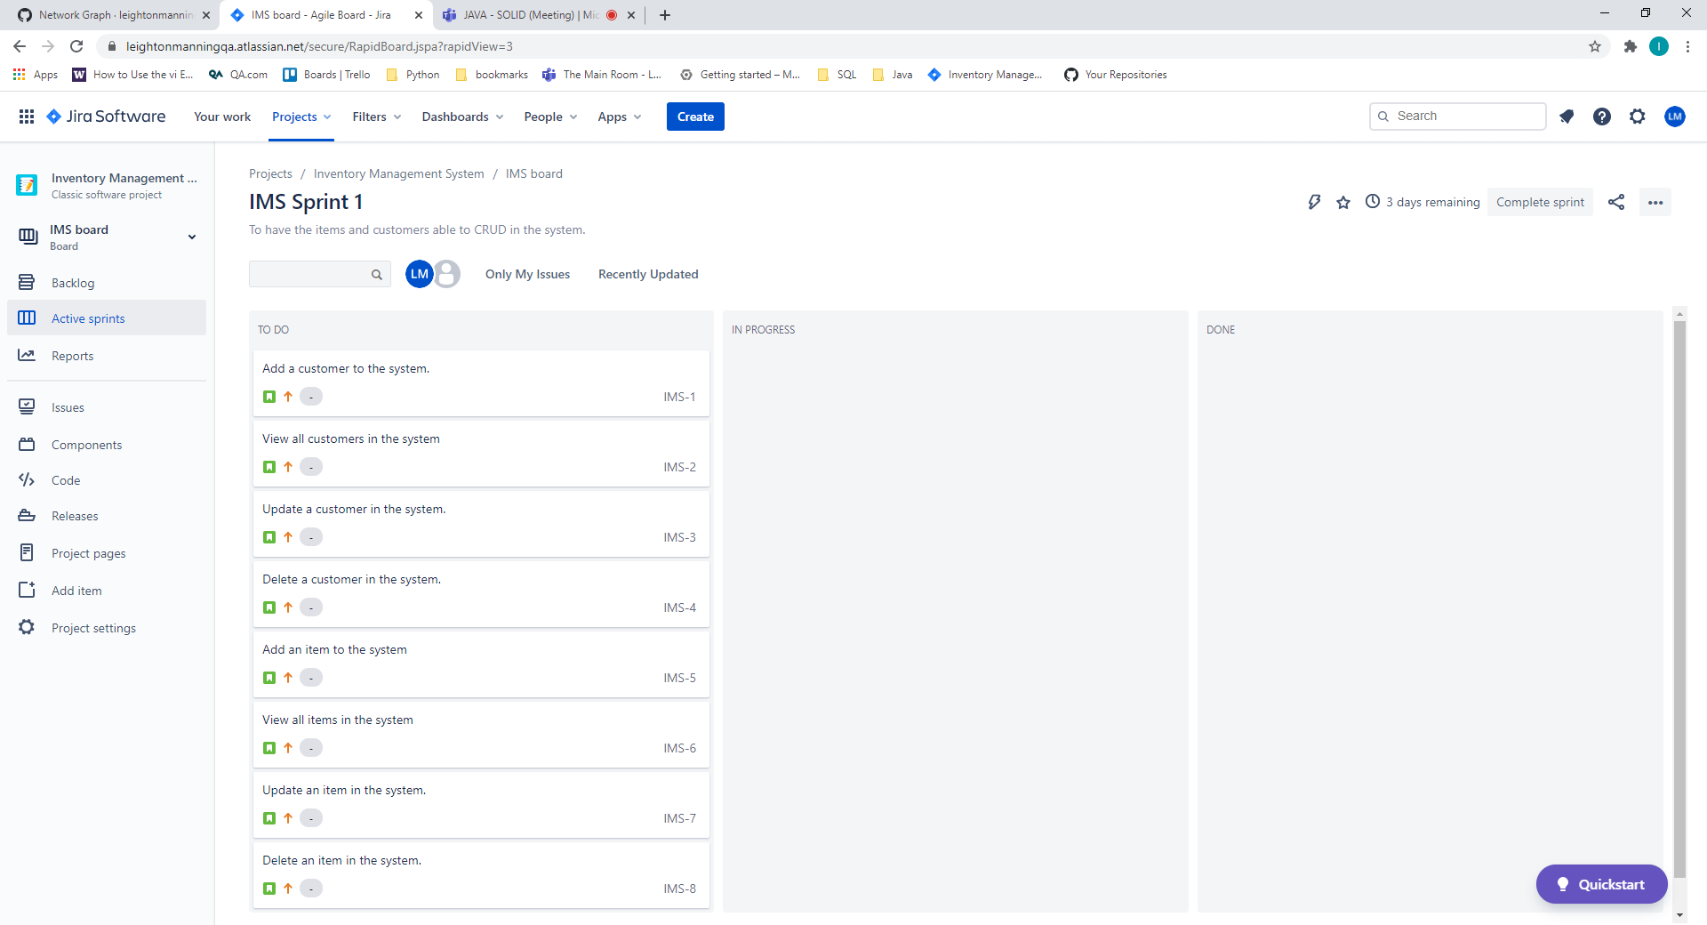

First week sprint was for items and customers able to CRUD.

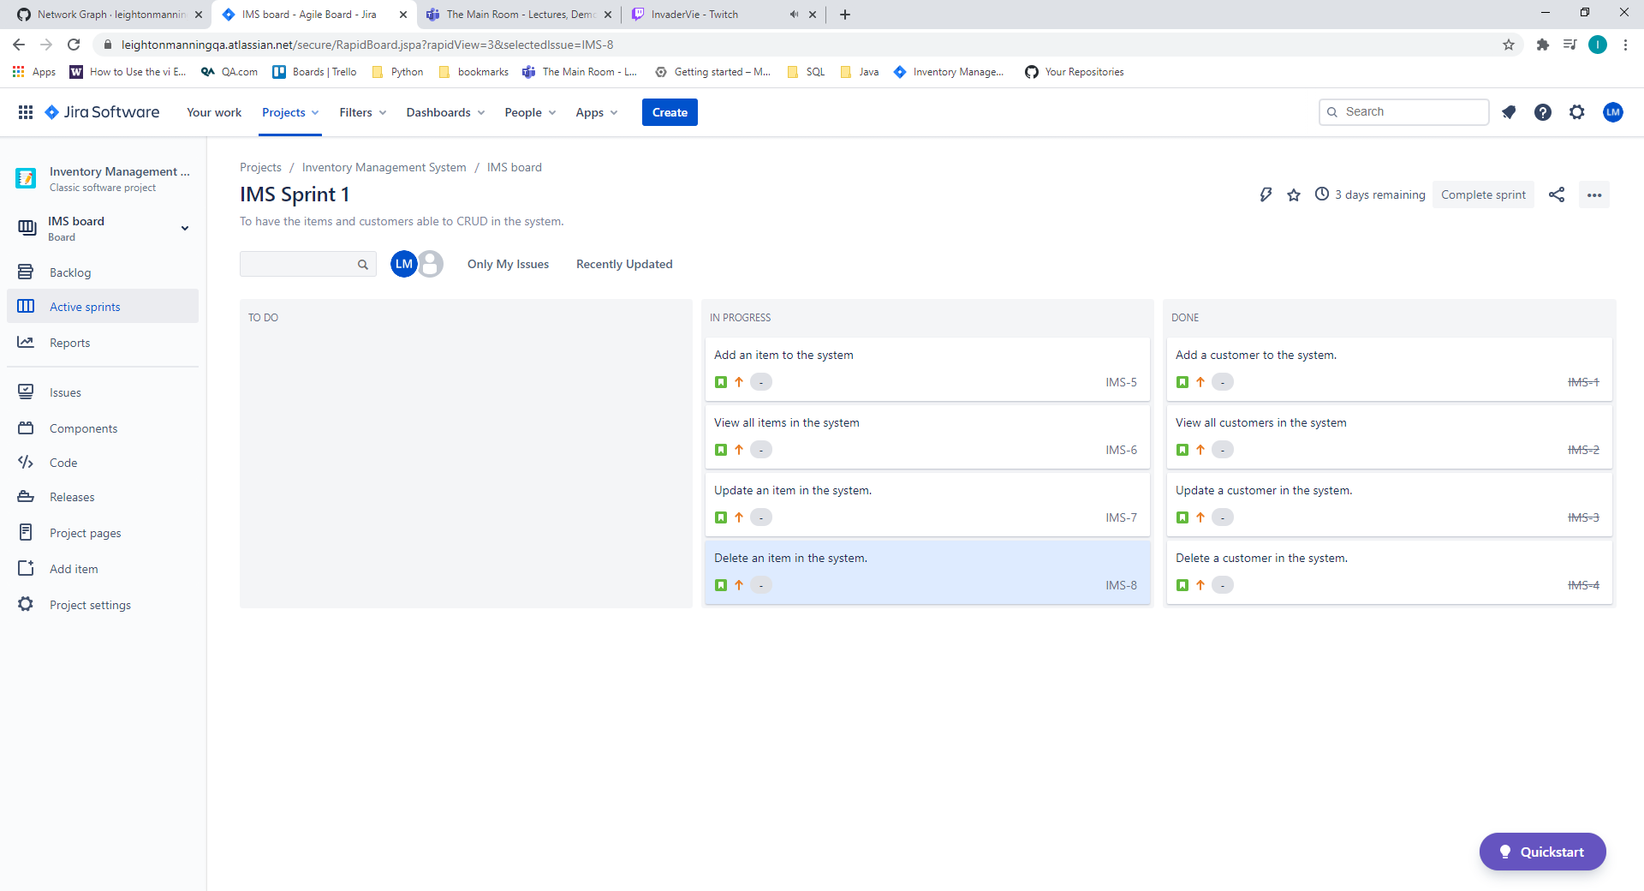 First made sure all the customer customer stories where working

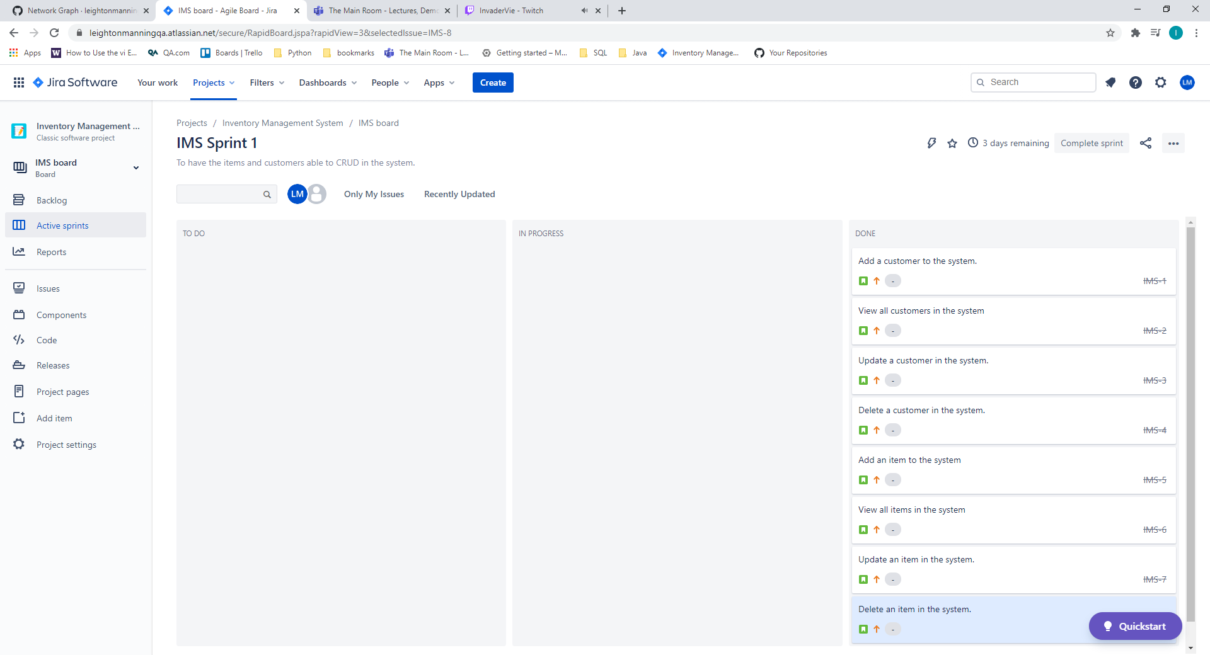

Finished item and customers. Both able to CRUD.

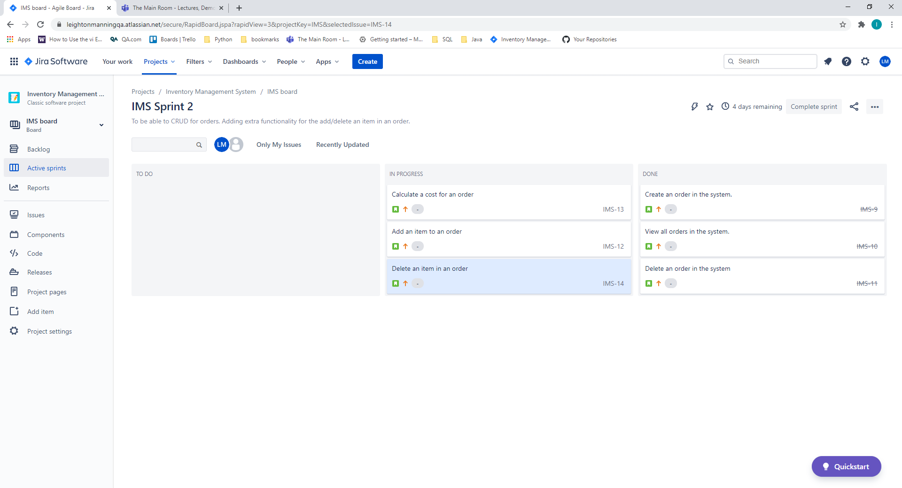

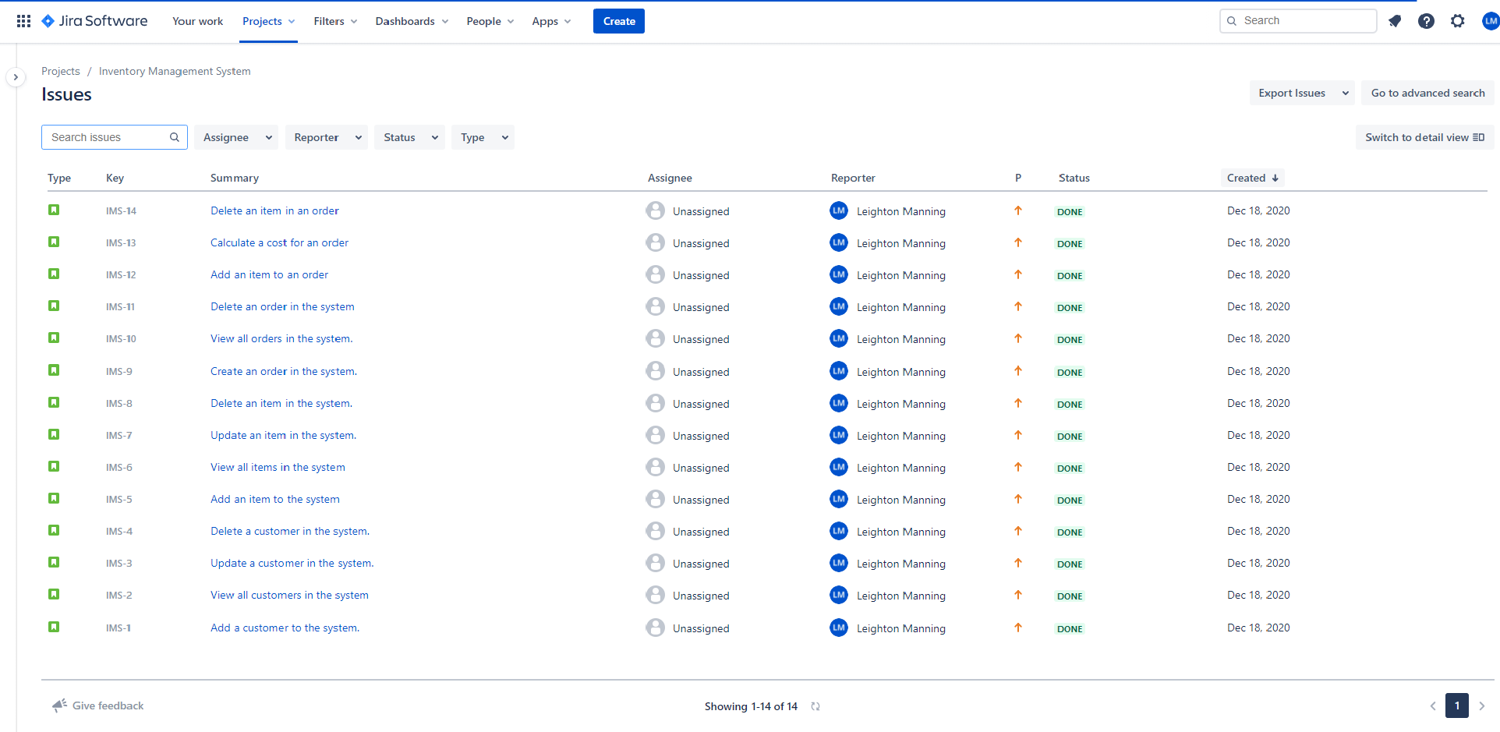Started working on being able to CRUD with orders. Completed that and then moved on to the final 3 customer stories.

Jira board completed.  
<https://leightonmanningqa.atlassian.net/jira/software/c/projects/IMS/issues/>